PROJECT REPORT

On

ALTERNATING CURRENT

Submitted by

S.J.EBEN GORKY



Guided by

Mr V.JEEVANANTHAM. M.sc.,M.ed

GEETHAANJALI ALL INDIA SENIOR SECONDARY SCHOOL

(Affliated to CBSC, Delhi)

CERTIFICATE



This is to certify that S.J.EBEN GORKY, Reg.No: of class XII science of successfully completed his project in physics on the topic of alternative current for the partial fulfilment of AISSCE as prescribed by CBSC in the year 2023-2024.

Viva voice held on:

Registration no:

*Signature of the signature of the*

GUIDE. PRINCIPLE.

*Signature of the signature of the*

INTERNAL EXAMINER. EXTERNAL EXAMINER.

ACKNOWLEDGEMENT

The success and final outcome of this project required a lot of guidance and assistance from many people and I am extremely fortunate to have got this all along the completion of my project work.

I am immensely grateful to my beloved principle Mrs.V.SUBBULAKSMI M.A., M.Ed., for her heavenly efforts and her involvement by providing timely suggestion and innovative ideas.

I am very pleased and humbled to my esteemed physics teacher V.JEEVANANTHAM M.sc., M.ed., for his adorable guidance and support to make this project a success.

I am gratitude to my precious parent who pleasured me with their remarkable drizzling of ideas. Then to my dearest GAISSS family who gave treasury of imagination.

INDEX

|  |  |  |
| --- | --- | --- |
| **Sr.No** | **CONTENTS** | **PAGE No.** |
| 1 | INTRODUCTION | 1 |
| 2 | ALTERNATING CURRENT IN A RESISTOR | 3 |
| 3 | PHASORS AND IT’S DIAGROM | 6 |
| 4 | AC VOLTAGE TO AN INDUCTOR | 9 |
| 5 | AC VOLTAGE TO AN CAPACITOR | 12 |
| 6 | LCR CIRCUIT | 15 |
| 7 | POWER IN AC CIRCUIT | 19 |
| 8 | LC OSCELLATIONS | 22 |
| 9 | TRANSFORMER | 26 |
| 10 | CONCLUSION | 28 |

**1. INTRODUCTION TO ALTERNATING CURRENT**

Alternating Current is a fundamental concept in the field of electrical engineering and power distribution. Unlike Direct Current, which flows steadily in one direction, AC is characterized by a continuously changing flow of electric charge. This nature of AC is what powers our homes, industries, and the technological infrastructure that surrounds us.

AC current varies in voltage and direction over time, typically following a sinusoidal waveform, with the direction of flow reversing at regular intervals. The frequency of these reversals, measured in Hertz (Hz), determines how rapidly the current changes direction. In most cases, AC systems operate at 50 or 60 Hz, depending on the region.

The origins of AC can be traced back to the pioneering work of inventors like Nikola Tesla and Michael Faraday in the 19th century. Tesla, in particular, played a pivotal role in the development and widespread adoption of AC as a means of transmitting electrical power over long distances.

AC significance lies not only in its efficient distribution capabilities but also in its adaptability to various applications. It powers our everyday lives, from lighting our homes and running our appliances to driving industrial machinery and charging our electronic devices. Understanding the principles and behaviour of AC is essential for engineers, electricians, and anyone seeking to grasp the complexities of the modern electrical grid and the technology that relies on it.

In this exploration of AC, we will delve into its fundamental characteristics and the behaviour of AC in various types of circuits, its relation with voltage and current. By the end of this project, you will have a deeper understanding of the dynamic force that powers our modern world.

**2. ALTERNATING CURRENT IN A RESISTOR**

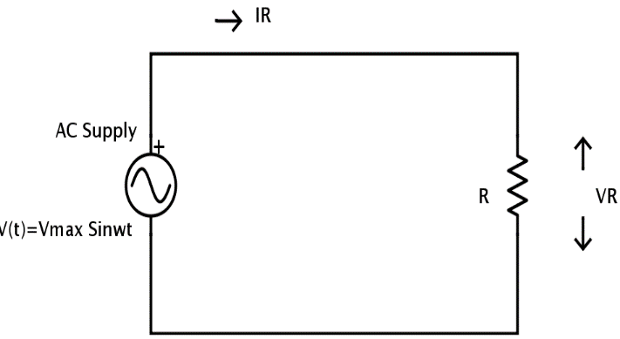

**Resistor Basics**:

A resistor is a passive electrical component that opposes the flow of current through it. It dissipates electrical energy in the form of heat. The resistance (R) of a resistor, measured in Ohms (Ω), quantifies its ability to restrict the flow of current. Ohm's law states that the voltage (V) across a resistor is directly proportional to the current (I) passing through it: V = I x R.

**AC Voltage Applied to a Resistor**:

When an AC voltage is applied to a resistor, the voltage across the resistor varies in the same way as the source voltage. For a sinusoidal AC voltage source with peak voltage V_peak and angular frequency ω (equal to 2π times the frequency), the voltage across the resistor at any given time t is given by:

V (t) = V_peak sin (ωt).

**Voltage and Current Relationship**:

According to Ohm's law, the current through the resistor is directly proportional to the voltage across it. For a resistor in an AC circuit, the relationship between voltage and current is linear, and the instantaneous current at any time t is given by:

I (t) = V (t) / R = (V_peak / R) sin (ωt).

**Phase Angle**:

In the case of a resistor, there is no phase difference between the applied voltage and the current flowing through it; they are said to be "in phase." The phase angle (φ) between voltage and current is zero degrees, indicating that voltage and current peak values occur at the same time in the waveform. This means that power is dissipated in the resistor continuously throughout the AC cycle.

**Power Dissipation in a Resistor**:

The instantaneous power (P (t)) dissipated in a resistor in an AC circuit can be calculated as:

P (t) = V (t) I (t) = (V_peak^2 / R) sin^2(ωt).

The average power (P_avg) over one complete AC cycle is given by:

P_avg = (1/2) (V_peak^2 / R).

Unlike in AC circuits with reactive components (inductors or capacitors), where power can be exchanged between the source and the component, in a resistor, power is continuously dissipated as heat.

**Effective (RMS) Values**:

In AC analysis, Root Mean Square (RMS) values are often used to represent the effective values of voltage and current. For a sine wave, the RMS value is equal to the peak value divided by the square root of 2: RMS = V_peak / √2. Using RMS values simplifies calculations, especially for power.

**Applications**:

AC voltage applied to a resistor is a fundamental concept in electrical engineering and electronics. Resistors are used in various applications where voltage division, current limiting, or signal conditioning is required. They are essential components in electronic circuits, such as voltage dividers, amplifier biasing networks, and signal termination.

**3. PHASORS AND its DIAGROM**

**Phasor Representation**:

In AC analysis, voltages and currents are often represented as phasors, which are vector-like quantities. A phasor is a rotating vector in a complex plane. Its length represents the magnitude of the AC quantity, and its angle relative to a reference axis represents the phase difference.

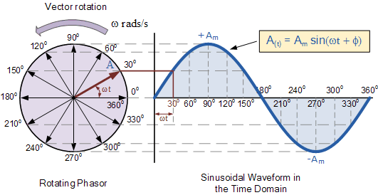

**AC Quantities as Phasors**:

AC voltage (V) and current (I) are typically represented as phasors. The peak value (V_peak) of the voltage waveform is represented as the length of the voltage phasor. The peak value (I_peak) of the current waveform is represented as the length of the current phasor. The phase angle (θ) between the voltage and current phasors indicates whether the current leads or lags the voltage.

**Phasor Diagram Construction**:

To construct a phasor diagram, you typically use a complex plane, where the horizontal axis represents the real part of the complex number (usually voltage), and the vertical axis represents the imaginary part (usually current). The phasors are drawn as vectors originating from the origin of the complex plane. The angle θ between the voltage and current phasors is measured counter clockwise from the voltage phasor to the current phasor.

**Leading and Lagging Phasors**:

If the current phasor leads the voltage phasor in phase (i.e., θ is positive), it is said to be leading. If the current phasor lags the voltage phasor (i.e., θ is negative), it is said to be lagging.

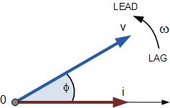 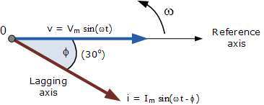

**Calculations with Phasor Diagrams**:

Phasor diagrams simplify calculations involving AC circuits, especially in the context of impedance (complex resistance), power factor, and power calculations. By using phasor diagrams, you can determine the relationship between voltage and current in capacitive and inductive AC circuits and calculate impedance (Z) and phase angle (φ).

**Example Applications**:

In a purely resistive AC circuit, the voltage and current phasors are in phase, forming a horizontal line in the complex plane. In a capacitive AC circuit, the current phasor leads the voltage phasor, and their angle is positive. In an inductive AC circuit, the current phasor lags the voltage phasor, and their angle is negative.

**Phasor Diagram for Power**:

Phasor diagrams are also useful for understanding power relationships in AC circuits. The real part of the power (P) can be determined by the product of voltage and current magnitudes times the cosine of the phase angle (P = V_peak * I_peak * cos (θ)). The apparent power (S), which represents the product of voltage and current magnitudes, is the length of the voltage phasor.

**4. AC VOLTAGE TO AN INDUCTOR**

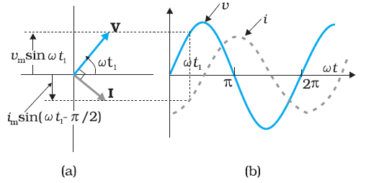

**Inductor Basics**:

An inductor is a passive electrical component characterized by its ability to store and release electrical energy in the form of a magnetic field. The inductance (L) of an inductor, measured in Henrys (H), quantifies its ability to oppose changes in current flow. In an ideal inductor, the voltage across it is directly proportional to the rate of change of current (dI/dt) passing through it: V = L (dI/dt).

**AC Voltage Applied to an Inductor**:

When an AC voltage is applied to an inductor, the voltage across the inductor continuously changes in accordance with the AC waveform. For a sinusoidal AC voltage source with peak voltage (V_peak) and angular frequency (ω), the voltage across the inductor at any given time (t) is given by:

V (t) = V_peak sin (ωt).

**Phase Shift in an Inductor**:

One of the key characteristics of an inductor in an AC circuit is the phase shift between the voltage (V) and current (I). Due to the inductive nature, an inductor resists changes in current, so it leads to a phase shift where the voltage across the inductor leads the current by 90 degrees (π/2 radians). Mathematically, you can represent this phase relationship as:

V (t) = V_peak sin (ωt)

I (t) = I_peak sin (ωt - π/2)

**Reactance and Impedance**:

In AC circuit analysis, the inductive property of an inductor is quantified using reactance (X_L), which is given by:

XL = ωL.

Reactance is similar to resistance (R) but is associated with the opposition to changes in current specifically caused by the inductor. The complex impedance (ZL) of an inductor is represented as ZL = XL. Impedance accounts for both resistance and reactance in AC circuits.

**Voltage and Current Relationship**:

Due to the phase shift, the voltage across an inductor leads the current by 90 degrees. This means that when the voltage is at its maximum (or minimum), the current is zero, and vice versa. The relationship between voltage and current in an inductor is described by:

V (t) = L (dI/dt)

**Energy Storage**:

One of the fundamental properties of inductors is their ability to store energy in the form of a magnetic field. During one-half of the AC cycle, energy is stored in the magnetic field as current increases, and during the other half, the energy is released as current decreases. This property is utilized in various applications, including transformers and inductors used in power supplies and filtering circuits.

**Practical Applications**:

Inductors are employed in AC circuits for a variety of purposes, including: Filtering out high-frequency noise in power supplies. Modifying the frequency response of circuits in analogue signal processing. Providing energy storage in power factor correction circuits. Transforming voltage levels in transformers.

**5. AC VOLTAGE TO A CAPACITOR**

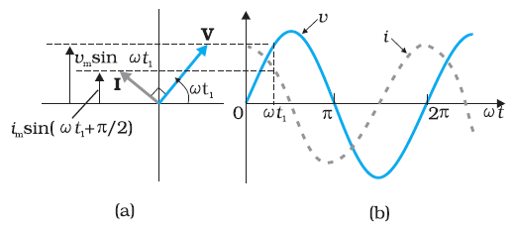

**Capacitor Basics**:

A capacitor is a passive electrical component that stores electrical energy in the form of an electric field between two conductive plates separated by an insulating material (dielectric). The capacitance (C) of a capacitor, measured in Farads (F), quantifies its ability to store electrical charge. In an ideal capacitor, the voltage across it is directly proportional to the integral of the current (I) passing through it over time:

.

**AC Voltage Applied to a Capacitor**:

When an AC voltage is applied to a capacitor, the voltage across the capacitor continuously changes in accordance with the AC waveform. For a sinusoidal AC voltage source with peak voltage (V_peak) and angular frequency (ω), the voltage across the capacitor at any given time (t) is given by:

V (t) = V_peak * sin (ωt).

**Phase Shift in a Capacitor**:

One of the key characteristics of a capacitor in an AC circuit is the phase shift between the voltage (V) and current (I). Due to the capacitive nature, a capacitor responds to changes in voltage by opposing them, leading to a phase shift where the voltage across the capacitor lags the current by 90 degrees (π/2 radians). Mathematically, you can represent this phase relationship as:

V (t) = V_peak sin (ωt)

I (t) = I_peak sin (ωt - π/2)

**Capacitive Reactance and Impedance**:

In AC circuit analysis, the capacitive property of a capacitor is quantified using capacitive reactance (XC), which is given by:

XC = 1 / (ωC).

Capacitive reactance is similar to resistance (R) but specifically reflects the opposition to changes in voltage caused by the capacitor. The complex impedance (Z_C) of a capacitor is represented as ZC = XC. Impedance accounts for both resistance and reactance in AC circuits.

**Voltage and Current Relationship**:

Due to the phase shift, the voltage across a capacitor lags the current by 90 degrees. This means that when the voltage is at its maximum (or minimum), the current is zero, and vice versa. The relationship between voltage and current in a capacitor is described by:

I (t) = C (dV/dt)

**Energy Storage**:

One of the fundamental properties of capacitors is their ability to store electrical energy in the form of an electric field. Energy is stored in the electric field as voltage increases, and it is released as voltage decreases. This property is utilized in various applications, including energy storage in electronic circuits and filtering out low-frequency noise in power supplies.

**Practical Applications**:

Capacitors are employed in AC circuits for a variety of purposes, including: Energy storage in electronic devices, such as flash cameras and backup power supplies. Coupling and decoupling capacitors in amplifiers and signal processing circuits. Filtering out low-frequency noise and providing phase shifting in audio and RF circuits. Power factor correction in electrical power distribution systems.

**6. LCR CIRCUIT**

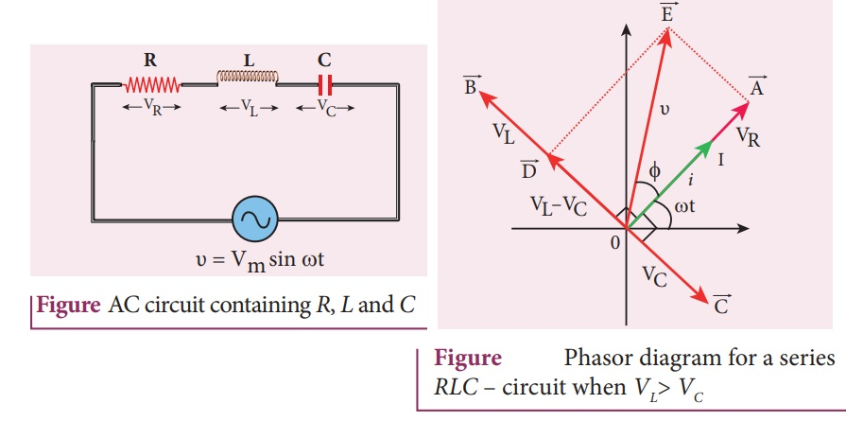

**Resistor (R)**:

The resistor is a passive component that resists the flow of electric current. It converts electrical energy into heat. In an LCR circuit, the resistor represents the resistive elements in the circuit, including wires and other components with resistance. The resistor is characterized by its resistance value, measured in Ohms (Ω).

**Inductor (L)**:

The inductor is another passive component that stores electrical energy in the form of a magnetic field when current flows through it. It opposes changes in current and causes a phase shift between voltage and current in AC circuits. The inductor is characterized by its inductance value, measured in Henrys (H).

**Capacitor (C)**:

The capacitor is an electrical component that stores electrical energy in the form of an electric field between two conductive plates separated by an insulating material (dielectric).It opposes changes in voltage and causes a phase shift between voltage and current in AC circuits. The capacitor is characterized by its capacitance value, measured in Farads (F).

**Series LCR Circuit**:

In a series LCR circuit, the components (resistor, inductor, and capacitor) are connected end to end in a single closed loop. The voltage across each component adds up to the total voltage applied to the circuit. The current through all components is the same, and the phase relationships between voltage and current vary for each component. Series LCR circuits are used in applications such as band pass filters and impedance matching.

**Instantaneous voltage and current in LCR circuit:**

Is the voltage across the LCR.

Since the voltage differ πrad voltage difference between inductor and capacitor is

By phasor diagram

Vr = Ri, VL = XLi, VC = XCi

V = Zi

Z =

By the phasor diagram ø =

Then instantaneous current is given by

I = ω t + ø)

I = ω t +)

**Parallel LCR Circuit**:

In a parallel LCR circuit, the components (resistor, inductor, and capacitor) are connected in parallel branches across the same voltage source. The voltage across each component is the same as the applied voltage. The total current entering the circuit is the sum of the currents through each branch, and the phase relationships between voltage and current differ for each component. Parallel LCR circuits are used in applications like power factor correction and impedance matching.

**Resonance in LCR Circuits**:

LCR circuits exhibit resonance when the inductive and capacitive reactance’s are equal, cancelling each other out. At this point, the impedance is at its minimum, and the circuits in a resonant state. Resonance in LCR circuits is characterized by maximum current and minimum impedance. Resonant LCR circuits are used in applications such as tuning circuits in radios and television sets.

**7. POWER IN AC CIRCUIT**

**AC LCR Circuit**:

In an AC LCR circuit, the power consists of two components: real power (active power) and reactive power. Real power represents the actual power consumed by the resistive elements (R), while reactive power represents the power oscillating between the inductive (L) and capacitive (C) elements.

**Real Power (P)**:

The power of the load or a conductor is given as P =

**By applying ohm’s law**

Real power represents the power dissipated in the resistive component (R) and is given by:

P =

Where: P is the real power in watts (W). I is the current amplitude (RMS value) in the circuit in amperes (A). R is the resistance in ohms (Ω).

**Reactive Power (Q)**:

Reactive power represents the power that oscillates between the inductive and capacitive elements, leading to a phase difference between voltage and current. It's given by:

Q =

Where: Q is the reactive power in volt-amperes reactive (VAR). I is the current amplitude (RMS value) in the circuit in amperes (A).X is the magnitude of the reactance (either inductive or capacitive) in ohms (Ω).

**Apparent Power (S):**

Apparent power represents the total power flowing into the circuit and is the vector sum of real and reactive power. It's given by:

S =

Where: S is the apparent power in volt-amperes (VA). P is the real power in watts (W). Q is the reactive power in volt-amperes reactive (VAR).

**Power Factor (PF)**:

The power factor (PF) of the circuit indicates the ratio of real power to apparent power. It's a value between 0 and 1 and is given by:

**Transient LCR Circuit**:

In transient LCR circuits, such as when switching an LCR circuit on or off, power can also be calculated, but the formulas differ. You'll need to consider the time-varying behaviour of voltage, current, and energy stored in the inductor and capacitor. The instantaneous power is given by:

P (t) = V (t) I (t)

Where:P (t) is the instantaneous power at time t.V (t) is the voltage at time t.I (t) is the current at time t.

**8. LC OSCELLATIONS**

**Components of an LC Oscillator**:

Inductor (L): An inductor stores energy in the form of a magnetic field and opposes changes in current. It is characterized by its inductance (measured in Henrys, H). Capacitor (C): A capacitor stores energy in the form of an electric field and opposes changes in voltage. It is characterized by its capacitance (measured in Farads, F).

**Energy Exchange**:

In an LC circuit, when the capacitor is charged, it stores electrical energy as electric potential energy in the electric field between its plates. When the capacitor is discharged, this stored energy is transferred to the inductor as magnetic potential energy in the magnetic field surrounding the inductor.

**Oscillatory Behaviour**:

When the capacitor and inductor are connected in parallel or series, and an initial charge is applied to the capacitor, the LC circuit will start to oscillate. The energy will continuously shift back and forth between the capacitor and the inductor, causing the voltage across the capacitor and the current through the inductor to oscillate sinusoidal motion.

**Natural Frequency (Resonant Frequency):**

The frequency of oscillation in an LC circuit is determined by the values of the inductance (L) and capacitance (C) and is known as the natural frequency or resonant frequency. The formula for the natural frequency is given by:

F =

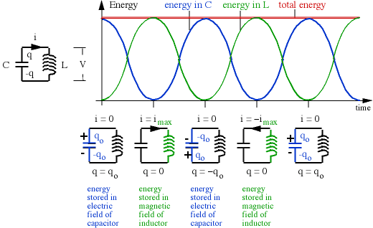

**Oscillation Frequency and Period**:

LC oscillators typically produce very high-frequency oscillations, especially in RF circuits the period of oscillation is the reciprocal of the frequency, given by:

T =

**Formula for UN damped LC Oscillations**:

Through Kirchhoff’s rule:

Is second derivatives if q w.r.t time (t)

Solving this second order differential equation givers

**Formula for Damped LRC Oscillations**:

Through Kirchhoff’s rule:

Is 2st derivatives if q w.r.t time (t) and

I is 1st derivatives of q w.r.t time (t)

Solving this second order differential equation givers

**Damping and Energy Loss**:

In practice, there is always some resistance (R) in the circuit, which causes damping. Damping results in the gradual loss of energy and eventual attenuation of the oscillations. The damping factor is quantified by the quality factor (Q) of the circuit. Higher Q indicates lower damping and more sustained oscillations.

**Applications of LC Oscillators**:

LC oscillators are used in various applications, including: RF signal generation in radio transmitters and receivers. Tuned circuits in radio frequency filters. Clock generation in electronic devices. Frequency synthesis in phase-locked loops (PLLs).

**LC Oscillator Circuits**:

Practical LC oscillators often incorporate additional components, such as transistors or operational amplifiers, to control and maintain oscillations. Examples of LC oscillator circuits include the Colpitts oscillator, Hartley oscillator, and Clapp oscillator.

**9. TRANSFORMER**

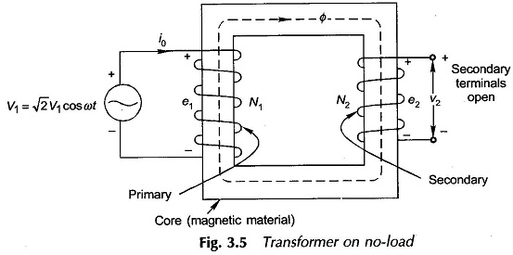

**Voltage (EMF) in a Transformer:**

The induced voltage (EMF) in a transformer can be calculated using Faraday's law of electromagnetic induction. According to Faraday's law, the induced EMF (E) in a coil is proportional to the rate of change of magnetic flux (Φ) through the coil. In a transformer, the induced voltage in the secondary coil is given by:

E = N

Where: **E** is the induced voltage in the secondary coil. **N** is the number of turns in the secondary coil. Is the rate of change in magnetic flux.

**Current in a Transformer**:

The current (**I**) in a coil of a transformer is determined by the voltage (**E**) and the impedance (**Z**) of the coil, following Ohm's law:

I =

​The impedance of the coil (**Z**) is related to the resistance (**R**) and reactance (**X**) of the coil:

Z =

Number of Loops (Turns) in a Transformer: The turns ratio (a) of a transformer is defined as the ratio of the number of turns in the secondary coil (N2) to the number of turns in the primary coil (N1): a = Now, combining these equations, we can derive formulas for voltage and current in terms of turns ratio and the number of turns: Voltage in the Secondary Coil

a =

V2 = a V1, Current in the Secondary Coil

​ a =

​I2 =

Equating a in equation

It's important to note that in practical transformers, the primary and secondary windings are typically wound on a common magnetic core, and the rate of change of magnetic flux () is determined by the primary coil. The turn’s ratio (N2)

**10. CONCLUSION**

* AC and DC (Direct Current) are two primary forms of electric current. AC periodically reverses its direction, while DC flows steadily in one direction. AC is commonly generated by power plants and is used in most household and industrial electrical systems.
* AC voltage and current vary sinusoidal over time, creating a waveform that oscillates between positive and negative cycles. The standard frequency for AC power in most regions is 50 or 60 Hertz (Hz), representing the number of cycles per second.
* AC is well-suited for long-distance power transmission because it can be easily transformed to different voltage levels using transformers, minimizing energy losses. It is versatile and can be easily converted to other forms of energy, such as mechanical energy in motors.
* Phasor diagrams are used to analyse AC circuits. They represent the magnitude and phase of AC voltages and currents, simplifying complex calculations. AC circuits exhibit properties like impedance (similar to resistance), reactance (caused by inductors and capacitors), and power factor (cosine of the phase angle between voltage and current).
* In AC circuits, voltage and current can have phase differences due to the presence of reactive components (inductors and capacitors). Leading and lagging are terms used to describe whether voltage leads or lags current in phase.
* AC is used in a wide range of applications, from powering homes and businesses to running industrial machinery. It is essential in electric motors, lighting systems, heating, ventilation, and air conditioning (HVAC), and more.
* AC generators (alternators) are used to convert mechanical energy into electrical AC energy by rotating coils within a magnetic field. Transformers enable voltage transformation in power distribution, allowing efficient transmission and distribution of electricity.
* AC remains the dominant form of electrical power globally, but emerging technologies, such as direct current (DC) distribution systems and renewable energy sources, are influencing the future of electrical grids and power systems. In conclusion, Alternating Current (AC) is a versatile and widely used form of electrical power characterized by its sinusoidal waveform and periodic reversal of direction. It is the cornerstone of modern electrical systems, facilitating the efficient generation, transmission, and utilization of electrical energy in our daily lives.